# T7: Exploring Greedy and 2-Opt

This is a team assignment designed as an in-class activity. It should be completed in your design team.

**Directions for use:**

* To use this form effectively, sign into a Google account.
* Then under “File” choose “Make a Copy” in order to be able to edit.
* Share with all team members, but allow the Recorder to do the recording.
* Each yellow box should be filled with an appropriate team response.
* Once complete, download as *yourteamname-T7.docx*.
* Upload *yourteamname-*T7.docx to Moodle.

## Member Roles

* If you have only three people, also combine Recorder & Spokesperson
* If you have five people, add a Process Analyst
* Make up a team name which suits your team!

|  |  |
| --- | --- |
| **Team Roles** | **Member Name** |
| **Facilitator:** Reads the questions aloud, keeps track of time, and makes sure everyone contributes appropriately. | **Shadia Prater** |
| **Recorder:** Records all answers and questions and uploads when complete. | **John Hellrung** |
| **Team Name:**  Make a name which is representative of your group (or just fun.) | **hellrungs** |

### The Traveling Salesman Problem (TSP)

Consider the following 10 city TSP problem:

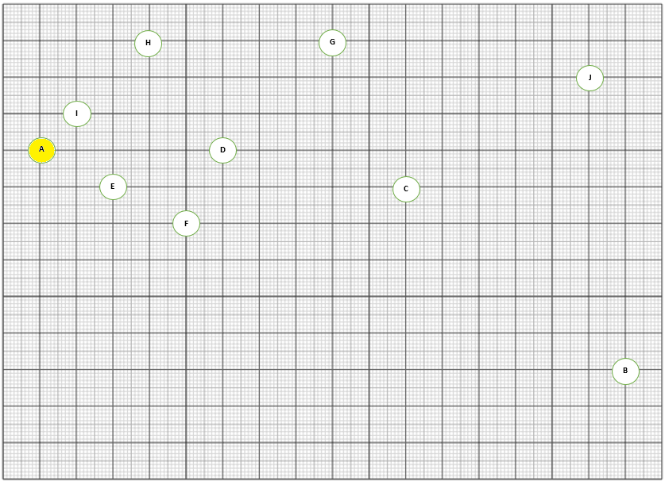

### NOTE:

Throughout this teamwork assignment, we will be computing tours by hand using the **distance formula**.   
If node A is at ( xA , yA ) and node B is at ( xB , yB ) then distance(A, B) = SQRT( ( xA - xB)**2 + ( yA - yB) **2),

|  |
| --- |
| Random Tour The above is a random tour to these 10 cities beginning at “A”.  Compute an estimate of the tour length of this tour given that the tiniest squares are 1 mile units. |
| (A,B) = 170.9 Miles, (B,G) = 120.4 Miles, (G,F) = 64.0 Miles, (F,J) = 117.0 Miles, (J,I) = 140.4 Miles, (I,H) = 28.3 Miles, (H,C) = 80.6 Miles, (C,E) = 80.0 Miles, (E,D) = 31.6 Miles, (D,A) = 50.0 Miles  Tour Length = 883.2 Miles |

|  |
| --- |
| Greedy Use the Greedy Heuristic to find a tour which begins at “A.”  Download <http://cs.berea.edu/courses/complexity/tasks/tsp-by-hand.png> and draw this tour on this image using Paint or other graphical software. Paste the image with the Greedy Tour below. |
|  |
| Compute an estimate of the tour length of this tour given that the tiniest squares are 1 mile units. |
| (A,C) = 100.5 Miles, (C,B) = 78.1 Miles, (B,J) = 80.6 Miles, (J,G) = 70.7 Miles, (G,H) = 50 Miles, (H,D) = 36.1 Miles, (D,F) = 22.4 Miles, (F,I) = 42.4 Miles, (I,E) = 22.4 Miles, (E,A) = 22.4 Miles  Tour Length = 525.6 Miles |
| Is the Greedy Tour better or worse than the random tour? By how much is is better or worse? |
| Worse. 357.6 Miles less. |

|  |
| --- |
| Brute Force   Showing your work, determine the number of possible tours of this set of cities which start at “A”. |
| 362880 Possibilities when starting with A. |
| Determine the amount of time it would take to use brute force to find the shortest tour which starts at “A” if each route could be computed in 0.000005 seconds. Show your work, and convert this to an appropriate unit (eg. days or years) so you can appreciate the size. |
| 362880 x 0.000005 = 1.8 Seconds - 0.0756 Days - 0.00020712328 Years |

|  |
| --- |
| 2-Opt Recall that the idea is to identify two edges which share no vertices, see if the cost improves by replacing them as follows:    We will use this idea beginning with the following tour:    Identify a set of edges which can be swapped in 2-Opt which will improve the tour. List the letters of the edges you will swap. |
| (A-D , E-C) |
| Download <http://cs.berea.edu/courses/complexity/tasks/tsp-by-hand.png> and draw this improved tour using a different color line for the two new edges. |
|  |
| Compute an estimate of the tour length of this tour given that the tiniest squares are 1 mile units. |
| (A,E) = 22.7 Miles, (B,G) = 120.4 Miles, (G,F) = 64.0 Miles, (F,J) = 117.0 Miles, (J,I) = 140.4 Miles, (I,H) = 28.3 Miles, (H,C) = 80.6 Miles, (C,E) = 80.0 Miles, (E,D) = 31.6 Miles, (D,A) = 50.0 Miles  Tour Length = 735 Miles |
| Identify another set of edges which can be swapped in 2-Opt which will improve the tour. List the letters of the edges you will swap. |
| (D,A - H,C) |
| Compute an estimate of the tour length of this tour given that the tiniest squares are 1 mile units. |
| (A,E) = 22.7 Miles, (B,G) = 120.4 Miles, (G,F) = 64.0 Miles, (F,J) = 117.0 Miles, (J,I) = 140.4 Miles, (I,H) = 28.3 Miles, (D,C) = 86 Miles, (C,E) = 80.0 Miles, (E,D) = 31.6 Miles, (H,A) = 42.4 Miles  Tour Length = 732.8 Miles |
| Repeat the 2-Opt process a few more times, computing tour length each time. |
| (A,H - I,J)  (A,I) = 14.1 Miles, (B,G) = 120.4 Miles, (G,F) = 64.0 Miles, (F,J) = 117.0 Miles, (J,H) = 140.4 Miles, (I,H) = 28.3 Miles, (D,C) = 86 Miles, (C,E) = 80.0 Miles, (E,D) = 31.6 Miles, (H,A) = 42.4 Miles  Tour Length = 724.2 Miles  ------------------------------------------  (F,J - D,C)  (A,I) = 14.1 Miles, (B,G) = 120.4 Miles, (G,F) = 64.0 Miles, (F,J) = 102 Miles, (J,H) = 140.4 Miles, (I,H) = 28.3 Miles, (F,C) = 60.8 Miles, (C,E) = 80.0 Miles, (E,D) = 31.6 Miles, (H,A) = 42.4 Miles  Tour Length = 703.2 Miles |

|  |
| --- |
| Greedy 2-Opt Rather than beginning with a random tour, 2 Opt sometimes begins with a tour found via a different heuristic.  Use the tour you obtained with the Greedy Heuristic to run a couple of iterations of 2-Opt, computing tour length each time. |
| (A,I) = 14.1 Miles, (I,E) = 22.4 Miles, (E,F) = 22.4 Miles, (F,D) = 22.4 Miles, (D,H) = 36 Miles, (H,G) = 50 Miles, (G,C) = 44.7 Miles, (C,J) = 58.3 Miles, (J,B) = 80.6 Miles, (B,A) = 170.8 Miles  Tour Length = 521.7 Miles  (A,B - C,J)  (A,I) = 14.1 Miles, (I,E) = 22.4 Miles, (E,F) = 22.4 Miles, (F,D) = 22.4 Miles, (D,H) = 36 Miles, (H,G) = 50 Miles, (G,C) = 44.7 Miles, (A,J) = 151.3 Miles, (J,B) = 80.6 Miles, (B,C) = 78.1 Miles  Tour Length = 522 Miles  (A,J - H,G)  (A,I) = 14.1 Miles, (I,E) = 22.4 Miles, (E,F) = 22.4 Miles, (F,D) = 22.4 Miles, (D,H) = 36 Miles, (H,J) = 80.6 Miles, (G,C) = 44.7 Miles, (A,G) = 44.7 Miles, (J,B) = 80.6 Miles, (B,C) = 78.1 Miles  Tour Length = 446 Miles |
| If a typical implementation of Greedy runs in O(n2 log2(n)) and an implementation of 2 Opt runs in O(n2), discuss the choice of initial map in 2 Opt. Do you think it is a good idea or not? Explain. |
| Yes because it is better |
| By storing the distance to the m nearest neighbors of each city, we can improve the complexity of 2 Opt further. Discuss the advantages and disadvantages of this idea over the use of the initial Greedy tour. |
|  |

### 

|  |
| --- |
| **Reaction**  Describe your design team’s reaction to this teamwork assignment. |
| This assignment is tedious and shows that this teamwork assignment is designed for busy work. After completing this assignment I realized that the explanation given to us about Heuristics gave us the information to satisfy your understanding of Heuristics 2-opt and Greedy, especially when you take in the condition of the class use their time outside of class to code both these Heuristics using the TSP example. I don’t feel that given us a teamwork assignment and targets that understanding of these two Heuristics along with the Lab 2 Assignment about these to same Heuristics is a great value of your time spend in class. I feel that these assignment should but less review using ridiculous questions. For example, asking us to add up the vertices distances using the distance formula. How is that relevant to understanding Heuristics and P vs NP. You could of easily show the result of the distance formula or any other result value and then had us compare the results.  Which proves that this yes this give us the time to comparison of these Heuristics but by make the assignment The reason is that for the last few week we are been going over Heuristics and this teamwork assignment shows that but is presented as an excuse to keep us busy in class. |

### Submission

To submit:

* The recorder will download this Google Doc worksheet as:
  + *yourteamname-T7.docx* and upload to Moodle.
  + *yourteamname-bruteforce.py*
* All other team members should submit the name of your team and all team mates.